How do we know how old things are? We use the science of radioactive decay to figure out how old an object is by how much ‘parent’ and ‘daughter’ isotope of a certain element is contained in the object. In this simulation you will use a Geiger counter to measure the amount of radioactive nuclide in an object, and estimate its age.
1. Definitions: Look these up in the lecture slides on radioisotope age dating. Please give the definitions, as defined in the slides (or look them up in your book or Wikipedia).
a) ISOTOPE:

b) What are the three isotopes of hydrogen (symbol H), and how many protons and neutrons are in the nucleus of each isotope?

c) ½ LIFE:

d) What happens to the atomic number (Z) and the mass number (A) of an atom when the nucleus undergoes beta⁻ decay? (β⁻) decay?

Give an example:

2. Simulation: Radiometric age dating of rocks and artifacts in buried sedimentary layers.
Go to https://phet.colorado.edu/sims/cheerpj/nuclear-physics/latest/nuclear-physics.html?simulation=radioactive-dating-game
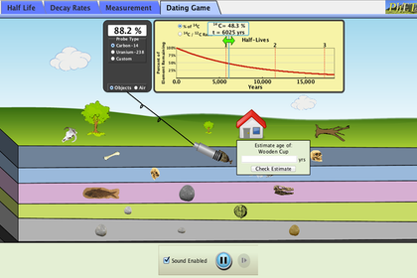
Click on the tab that says “Dating Game” (tab #4).
How to play:
1) Drag the end of the Geiger counter (a device for measuring radioactivity) to a rock or a fossil. Choose which radioisotope you will measure: C-14 or U-238, based on the following information (also described in the slides on radioactivity):
isotope | half life | useful range of ages that can be determined
Carbon-14 | 5730 years | 100 to 700,000 years
Uranium-238 | 4.5 billion years | 10 million to 4.6 billion

If you choose the wrong isotope, you will get a blank in the percentage box connected to the Geiger counter; if you choose the appropriate isotope, you will get a percentage, telling you how much of the parent isotope is remaining.
2) Drag the double-sided green (or yellow) arrow along the decay curve (right or left) until the percentage shown in the box above the arrow matches that in the percentage box on the Geiger counter. Then read the age, and enter that into the box next to the object that says, “Estimate age of Sample x.” Be sure to enter your value in YEARS. For example, 783.70 MY = 783,700,000 years, so you would enter this number in the box. Click “Check Estimate” to check your answer. You get a response from the system if you get it right or wrong!
QUESTION 1: For the skulls near the top of the geologic layers, C-14 works. When you get down to the fossil of the fish and the dinosaur skull, C-14 won’t work. WHY NOT? (Hint: Look at the table of half lives and useful age ranges. Dinosaurs died out by 65 million years ago.)

QUESTION 2: If you can’t get a direct age measurement for the dinosaur skull or fish skeleton, but you can get an age of the rock in the same geologic layer using U-238, how can you tell the ages of the fossils?

Now get ages for all the buried objects and write them in the following table. For Isotope, put C-14 or U-238. For the fossils that are too old to have any measurable C-14, but do not contain any uranium, state how you estimated their ages.
LAYER | OBJECT | ISOTOPE | AGE
Top | animal skull
 | tree stump
1 | bone
 | cup
 | human skull
2 | human skull
 | fish bones
3 | fish fossil
 | Rock 1
 | Dinosaur skull
4 | Rock 2
 | Trilobite
5 | Rock 3
 | Rock 4
 | Rock 5

